Children’s Book Project
- You are to write and illustrate a children’s book using the vocabulary that you have learned this year in math.
- You may pick a Book type: Poetry, comic book style, cartoon style, story book style, riddles, etc.
- The finished book can be in your handwriting or typed, but it must be neatly written and organized just like a child’s book.
- The book must be bound in some way (staples, ties, portfolio folder, binder, etc.). It must have an illustrated cover with a clear title.
- Each book must be at least ten pages (including the cover) that include a specific theme. See the rubric for all requirements.

Vocabulary Ideas
Line, triangle, midpoint, bisect, perpendicular, angle, square, hexagon, equilateral, median, altitude, parallel, slope, y-intercept, horizontal, vertical, circle, locus, point, reflection, rotation, translation, dilation, rotation, distance, area, perimeter, volume, sine, cosine, tangent, surface area

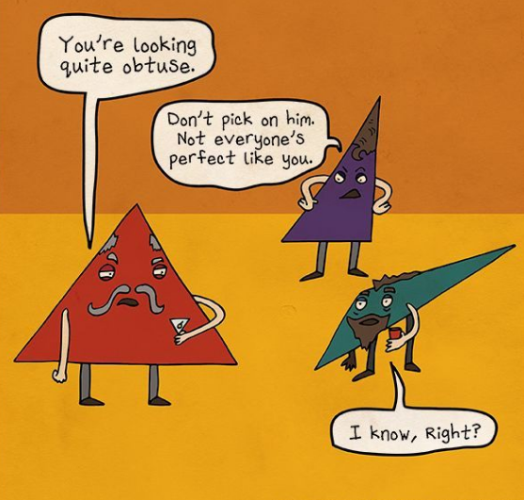
Page examples:
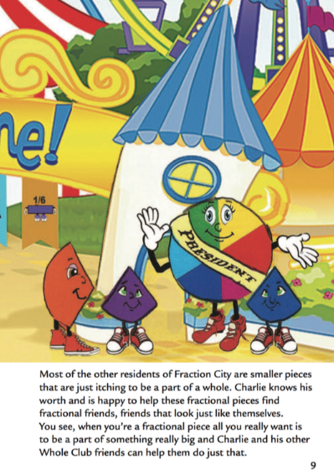

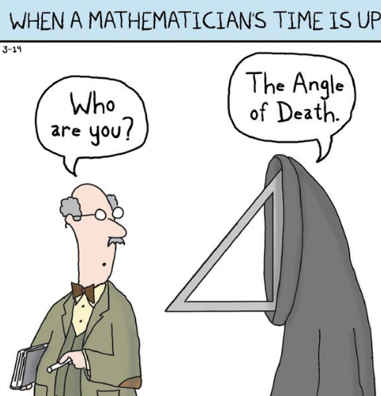

RUBRIC
 | 3 | 2 | 1 | 0
Cover | Cover was creative and colorful. | Cover was creative but not colorful | Cover was not colorful nor creative. | There was no cover.
Binding | Book was bound |  |  | Book was not bound.
Illustrations | All 10 pages included illustrations. | 2-3 pages did not have an illustration. | More than 3 pages did not have an illustration. | Book was incomplete.
Words/Story line | Each page went with the story theme. | 1-3 pages did not go with the theme. | 4 or more pages did not go with the theme. | No theme was evident.
Mathematics | All pages included at least one math word. | 1-2 pages did not include a math word. | 3 pages did not include a math word. | 4 or more pages did not include a math word.
Lateness | No books will be accepted late

